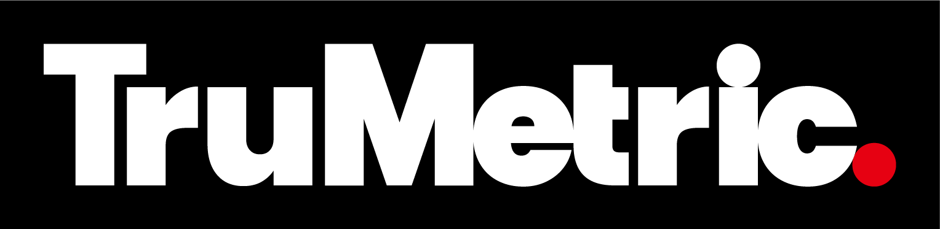

FOR IMMEDIATE RELEASE
April 14, 2026

TruMetric Launches as a National Calibration Platform
Formed by the unification of Micro Quality Calibration and Technical Maintenance Inc. to deliver accredited services nationwide.

GREENSBORO, Georgia — Micro Quality Calibration (MQC) and Technical Maintenance Inc. (TMI), two established full-service calibration organizations, announced the formation of TruMetric, a new family of companies combining their industry-leading capabilities to deliver accredited calibration services nationwide.

The partnership brings together MQC’s accredited laboratory and on-site calibration expertise with TMI’s strong field presence and embedded lab models. Built on more than 75 years of combined experience, the TruMetric family of brands represents the evolution of both organizations, creating a centralized calibration provider designed to support comprehensive calibration and repair services across regulated industries.

“I couldn’t be more excited to be part of the creation of TruMetric. When you take one of the most dominant calibration facilities of the east and pair it with one of the most dominant calibration facilities on the west, you have just created the most premier laboratory in the country,” said Michael Floyd, chief executive officer of TruMetric and co-founder of TMI. “It is going to be fun filling in the small gaps and giving our customers the very best option for their national calibration needs.”

“By uniting the proven strength of MQC and TMI, we are not just expanding — we are setting a new benchmark for what a national calibration provider should be,” said Nick Gontmaher, TruMetric West Coast operations leader and president of MQC. “TruMetric brings together unmatched technical capability, geographic reach, a shared commitment to customer success, and a relentless focus on quality, creating the premier calibration platform in the country. Our customers now have a single partner that can deliver consistency, scale, and performance at a level that simply does not exist elsewhere in the market.”

Through TruMetric, customers will gain increased access to calibration services across a range of measurement types, including dimensional, mechanical, electrical, RF / microwave, thermodynamics, pressure, torque and many more. Via a consultative approach, services are tailored to each customer’s needs and can be delivered through accredited laboratories, on-site support, embedded lab models, and mobile solutions.

Many regulated companies are facing increasing regulatory requirements and higher equipment costs. The new partnership positions TruMetric to meet growing demand for accurate and timely calibration services. Certified by A2LA to ISO 17025 requirements, TruMetric supports organizations in strengthening quality systems, meeting compliance demands, and improving equipment reliability.

TruMetric supports more than 10,000 customers across the United States, ranging from small businesses to leaders in aerospace, defense, automotive, biomedical, communications, and electronic industries. With more than 5,800 accredited capabilities, 15 full-service laboratories and over 20 embedded lab locations — supported by a team of more than 400 professionals — TruMetric offers one of the most comprehensive scopes of accreditation in the nation, delivering best-in-industry turnaround times.

Customers of MQC and TMI will continue working with the same teams and locations. As foundational organizations within TruMetric, MQC and TMI will continue to ensure continuity of service while expanding access to additional capabilities and resources through TruMetric.

With the formation of TruMetric, MQC and TMI are embarking on a new journey together, one that starts with a shared legacy of calibration excellence and stretches far into the future. Learn more about the formation of TruMetric by watching our legacy video.

About TruMetric
TruMetric provides accredited calibration, measurement, and testing across the nation. TruMetric laboratories operate under internationally recognized accreditation and quality frameworks, and are committed to upholding the highest standards of calibration excellence. TruMetric provides full-service calibration through in-house, on-site, embedded tech, embedded lab, and mobile solutions. Additional information about TruMetric can be found at TruMetric.com.

About Micro Quality Calibration, LLC
Founded in 1978, Micro Quality Calibration (MQC) is a full-service lab providing a consultative approach to calibration and repair services through three accredited laboratories in the Greater Los Angeles area. MQC serves the major leaders in defense, aerospace, automotive, medical, and more. MQC is a part of the TruMetric family of companies.

About Technical Maintenance Incorporated, Inc.
Founded in 1991, Technical Maintenance Incorporated (TMI) is a full-service ISO 17025 accredited calibration provider with 11 full-service labs and many embedded labs across the U.S. TMI is a part of the TruMetric family of companies.

